**Specialist Mathematics Units 3 & 4**

**Test 3 2018**

**Calculator Free Section**

**Name: __________________________ Score: _____ / 22**

**Time Allowed**: 20 minutes

**No calculators or notes are to be used.**

**Access to approved Mathematics Specialist formulae sheet is permitted.**

Where a question or part of a question is worth more than 2 marks sufficient working to justify your solution is required

**1. [ 4 marks ]**

MNOPQRST is a rectangular prism with **OP = *p***, **ON = *n* and OS = *s*.**

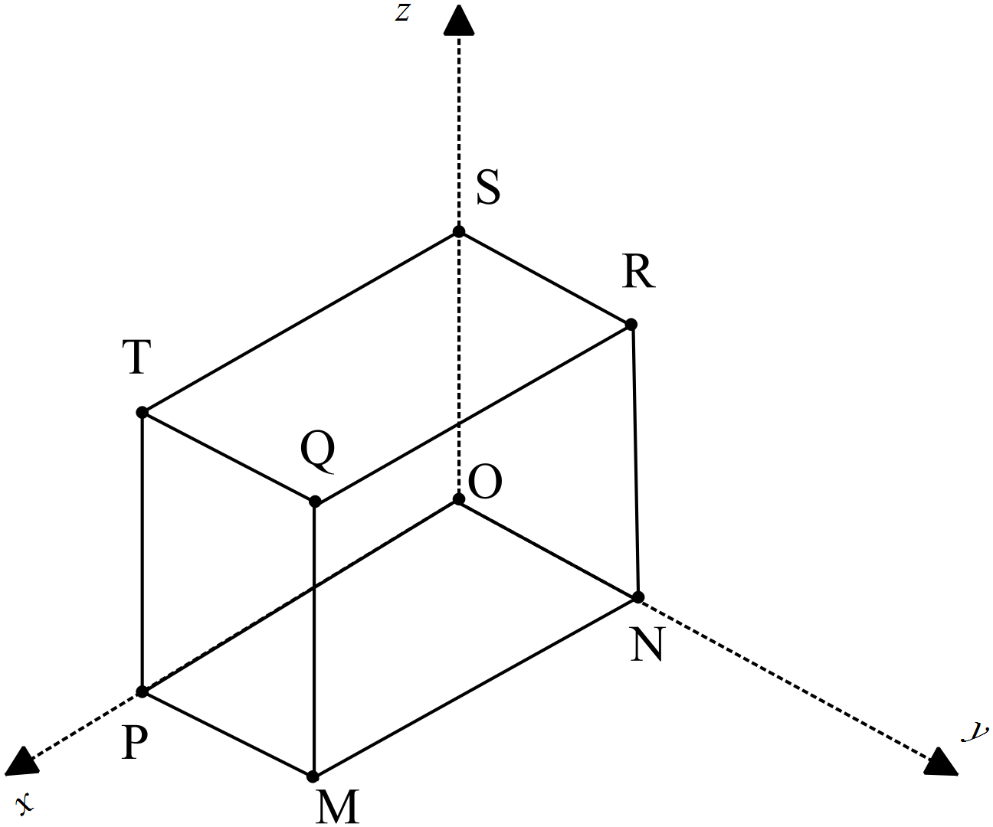

**O** is the origin of the ***x***-***y***-***z*** axes.

Use the fact that $a×b=\left|a\right|\left|b\right|sinθ$ and $a.b= \left|a\right|\left|b\right|cosθ$**to** prove that the volume of the cuboid is $\left|\left(p×n\right).s\right|$

The area of the base is $\left|p×n\right|$ because it equals $\left|p\right|\left|n\right|×1$ since **p** and **n** are perpendicular and $sin{90}^{°}$ =1 ✓

The height is $\left|s\right|$, therefore the volume is ✓

**p**×**n and $s$ are parallel so**

$\left|cos0°\right|$ or = ✓

**Therefore $\left|\left(p×n\right).s\right|=\left|p×n\right|\left|s\right|=$** volume of the cuboid ✓

**2. [ 5,1 = 6 marks]**

A plane Γ contains the points P at position **k –** 2**j,** Q at 4**i** + **j** +3**k** and R at 2**k** – **i.**

**a)** Determine a vector equation which contains the normal to the plane.

PR = $\left[\begin{matrix}-1 \\ 0 \\ 2\end{matrix}\right]-\left[\begin{matrix}0 \\ -2 \\ 1\end{matrix}\right]$ = $\left[\begin{matrix}-1 \\ 2 \\ 1\end{matrix}\right]$

PQ = $\left[\begin{matrix}4 \\ 1 \\ 3\end{matrix}\right]-\left[\begin{matrix}0 \\ -2 \\ 1\end{matrix}\right]$ = $\left[\begin{matrix}4 \\ 3 \\ 2\end{matrix}\right]$ or QR = = ✓

PR

=

= ✓✓ (-1 each mistake)

Using P,  **r.n = $\left[\begin{matrix}0 \\ -2 \\ 1\end{matrix}\right]. \left[\begin{matrix}1 \\ 6 \\ -11\end{matrix}\right]$**  = -23 ✓

So **r.**  ✓

**b)** Express this as a Cartesian equation.

*x* + 6*y -* 11*z* = -23 or *x* + 6*y -* 11*z* + 23 = 0 ✓

**3. [1, 1, 3 = 5 marks ]**

A point P moves in a path according to the parametric equations: $x=2\cos{t}, y=3\sin{t , }$ where $t≥0$

1. Give the Cartesian equation of the path

$\frac{x^{2}}{4}+\frac{y^{2}}{9}=$ $\frac{{(2\cos{t}}^{)2}}{4}+\frac{({3\sin{t) }}^{2}}{9}= \cos{t^{2}+ \sin{t^{2}}{=1}}$

So ✓

1. State the velocity vector of the ellipse

✓

1. Draw the path traced by P, indicating its direction clearly and key points

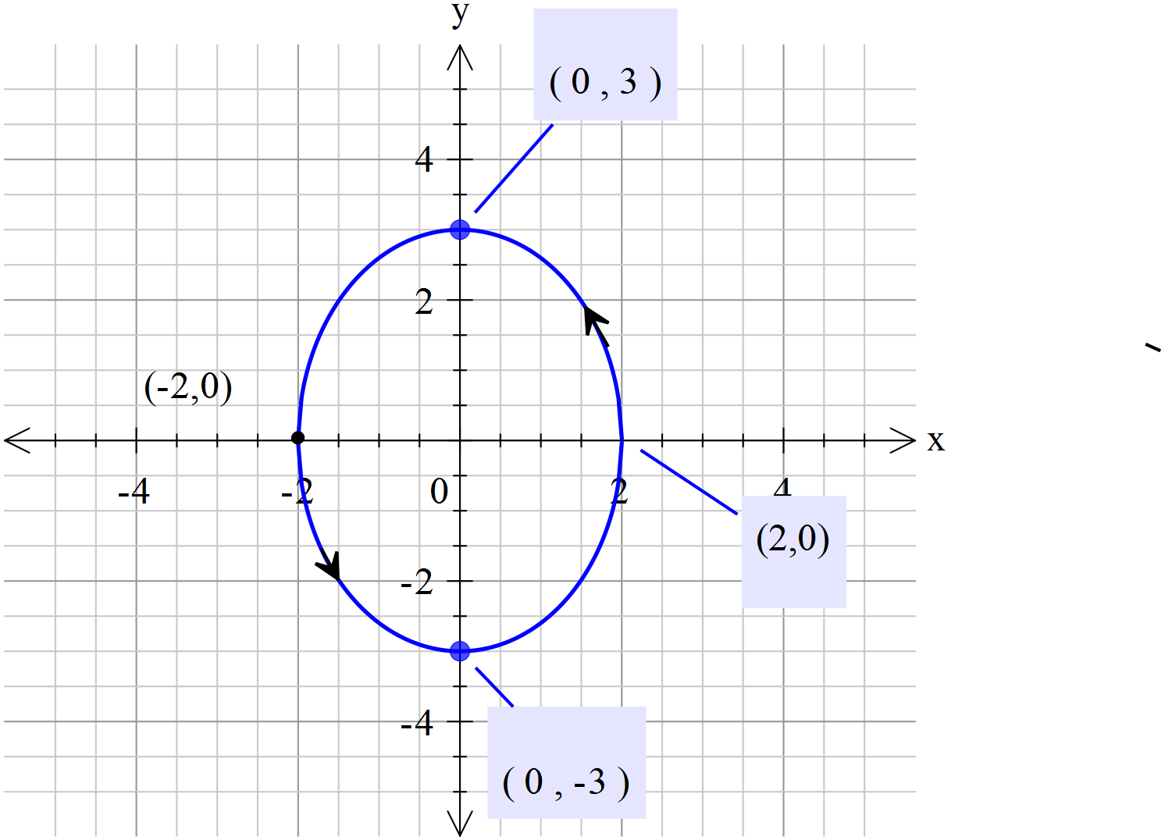

Shape of path ✓

Direction correct ✓

Scale/points shown ✓

**4. [4, 1, 2 = 7 marks]**

|  |  |  |  |  |  |  |
| --- | --- | --- | --- | --- | --- | --- |
| x | + | 3y | - | z | = | 5 |
| 2x | + | 7y | - | 3z | = | 6 |
| -x | - | y | + | (p2-p-1)z | = | p-13 |

For what value of p will the above system of equations have

1. an infinite number of solutions,



 ✓✓

 ✓

An infinite number of solutions when p = 0 ✓

1. no solutions

No solution when p = 1 ✓

1. a unique solution?

A unique solution when pand p  ✓✓

**Specialist Mathematics Units 3 & 4**

**Test 3 2018**

**Calculator Assumed Section**

**Name: _______________________ Score: _____ / 25**

**Time Allowed**: 25 minutes

**Materials Allowed**: SCSA formula booklet, SCSA approved calculators and one A4 page of notes (both sides).

**Instructions:** Where a question or part of a question is worth more than 2 marks sufficient working to justify your solution is required.

5. [1,1,3 ,4 = 9 marks ]

The Cartesian equation of plane ∏ is .

**a)** State a vector equation of this plane.



A correct vector equation (many are possible but only one is obvious) ✓

The parametric equations of line  are .

**b)** State a vector equation for line .



A correct vector equation (many are possible but only one is obvious) ✓

**c)** Determine the position vector of , the point of intersection of line  and the plane.



Substitutes expression for **r** in equation of line into equation of plane. ✓

Solves for $λ$ =-4 ✓

Correct position vector for A ✓

d) Determine the angle between Line L and plane ∏

cos Θ = $\left[\begin{matrix}2 \\ -1 \\ \end{matrix}\right].$

**d)** Determine the acute angle $α$ between Line L and plane ∏ to the nearest tenth of a degree.

cos Θ = $\frac{\left[\begin{matrix}2 \\ -1 \\ 1\end{matrix}\right].\left[\begin{matrix}1 \\ 2 \\ -1\end{matrix}\right]}{\left|\left|\begin{matrix}2 \\ -1 \\ 1\end{matrix}\right|×\left|\begin{matrix}1 \\ 2 \\ -1\end{matrix}\right|\right|}$ $α$ 
  
 = 180 - $\cos^{-1}\left(\frac{-1}{5.916}\right)$

$α$ = 99.6 $°$, acute version is 80.4 $°$

so angle at plane is 9.6 $°$. Alternatively or $α$ = $\sin^{-1}\left(\frac{-1}{5.916}\right)$ = 9.6 $°$.

Uses dot product formula to give an expression for the supplementary angle. ✓

Uses inverse of trig ratio to find angle ✓

Adjusts for acute angle (or uses sin of dot product ) ✓

Correct angle for ✓

6. [ 5, 2, 2, 3, 2 = 12 marks]

For a particle projected from the Origin with speed µ ms-1 at an angle of $Θ$ $0<θ^{°} <90)$ with the positive x-axis, the position vector at time $t$ seconds is $r\left(t\right)=ucosθti+\left(usinθt-5t^{2}\right)j$ metres. The equation of the path of the particle is given by

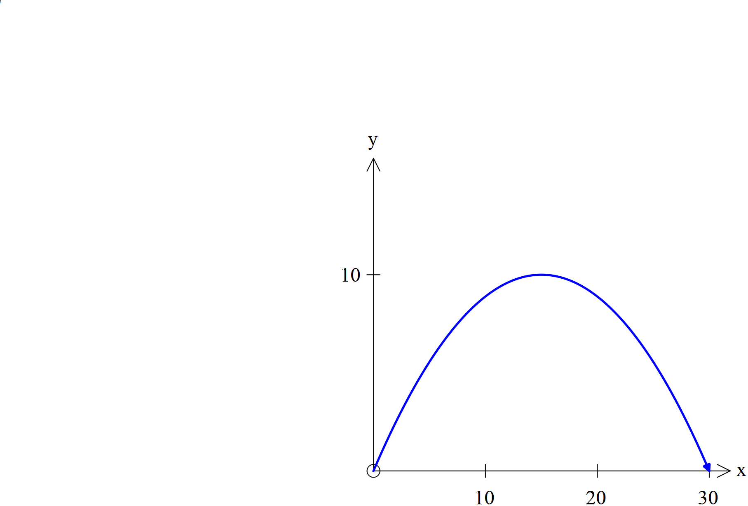

The diagram featured shows the path of the particle.

The equation of the path of P is $=\frac{4x}{3}-\frac{2x^{2}}{45}$.

**a)** State the position vector of P at time $t$ seconds.

Comparing the two equations:

$xtanθ=\frac{4x}{3}$

So ✓ also sin $θ$ = $\frac{4}{5}$ and cos $θ$ = $\frac{3}{5}$

Also [(5(1+(/] ✓

Therefore ✓ , using calculator

So

✓✓

**b)** Use vector methods to find the direction of the particle at time $t=1$ seconds .

✓

✓

= 21.33185286 $°$ or 0.3723110679 radians ✓

**c)** Use vector methods to find the distance travelled by P along its path, from the time of the projection to the time it hits the $x$-axis again. Show clearly how you obtained your answer.

When it hits the ground ✓

Therefore $t=2\sqrt{2}$ seconds as ✓

Distance along path is ✓

= 37.35938825 metres ✓

**7. [ 4 marks ]**

Prove that the line ***r*** = $〈3,0,2〉+λ〈2,2,-1〉$ is a tangent to the sphere with equation (x-2)2+(y-1)2+(z+1)2 =

Change sphere formula to vector equation ✓

Substitute $\left[\begin{matrix}2λ+3 \\ 2λ \\ 2-λ\end{matrix}\right]$ into $\left|r-\left[\begin{matrix}2 \\ 1 \\ -1\end{matrix}\right]\right|=\sqrt{10}$

Giving ✓

Solving ${(2λ+1)}^{2}+{(2λ-1)}^{2}+{(3-λ)}^{2}=10$

Gives ✓

Since there is only one point where the line touches the sphere it is a tangent. ✓

**8.** **[ 2,2,2,2= 8 marks ]**

Three particles A, B & C are such that their initial positions relative to the Origin at a given time are < 0, -1, -2> m ; < 4, 1, 6 > m and < -4, 1, -2> m respectively. Their constant velocities are < 1, 2, 2 >ms-1, < -1, α, -2 > ms-1 and < 3, 1, β >ms-1 , also respectively.

**a)** State the position vectors of each particle after *t*  seconds

OA = $\left[\begin{matrix}0 \\ -1 \\ -2\end{matrix}\right]$ +t $\left[\begin{matrix}1 \\ 2 \\ 2\end{matrix}\right]$ OB = $\left[\begin{matrix}4 \\ 1 \\ 6\end{matrix}\right]$ +t $\left[\begin{matrix}-1 \\ α \\ -2\end{matrix}\right]$ OC = $\left[\begin{matrix}-4 \\ 1 \\ -2\end{matrix}\right]$ +t ✓✓ (-1 each mistake)

or

OA = $\left[\begin{matrix}t \\ 2t-1 \\ 2t-2\end{matrix}\right]$ OB = $\left[\begin{matrix}4-t \\ αt+1 \\ -2t+6\end{matrix}\right]$ OC = $\left[\begin{matrix}-4+3t \\ t+1 \\ βt-2\end{matrix}\right]$

**b)** If these velocities are maintained all three will collide. Use vector methods to determine the values of α and β.

Comparing **i**  components , *t = 4-t = 3t-4 giving t = 2* ✓

Comparing **j**  components , 2t+1 = $αt$ +1 = t + 1

When t = 2, α = 1

Comparing k components , 2t -2 = 6 – 2t = $βt-2$

When t = 2, $β$ = 2 ✓

**c)** If these velocities are maintained only A and B will collide. Use vector methods to determine the possible values of α and β in this instance.

A, B & C collide at t = 2 seconds for α = 1 and $β$ = 2

For A & B to collide t = 2 and α = 1 ✓

For C not to collide with them ✓

**d)** If these velocities are maintained only two of the three will collide. Use vector methods to determine the possible values of α and β in this instance.

For two only to collide α = 1 or $β$ = 2, since when both are true all three collide. If neither are true ie α $≠$ 1 and $β≠$ 2 , no collision will occur ✓✓